НИУ МИЭТ

|  |
| --- |
| Системотехника ИУС |
| Отчет №3 |
| Выполнил Назлуян Давид, студент МП-42 |

|  |
| --- |
| Давид Назлуян  24.3.2015 |

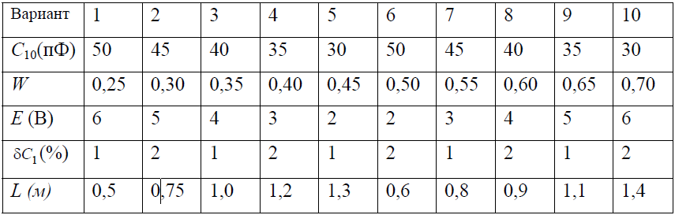

Схема 1:

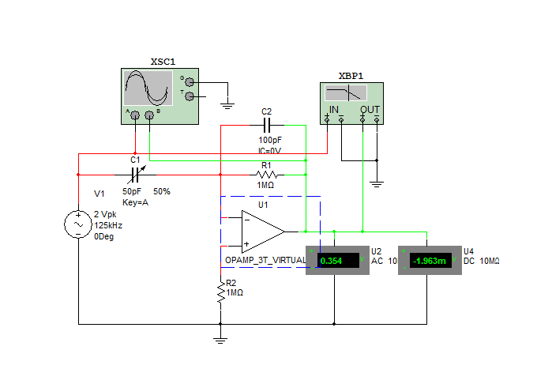

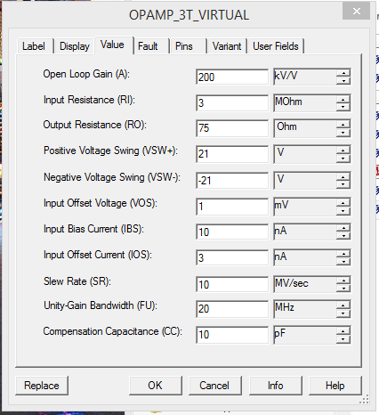

Расчеты:

Спар = 50пФ/м*0.6м = 30пФ

С2 = С1/W = 50пФ/0.5 = 100пФ

**Осциллограмма:**

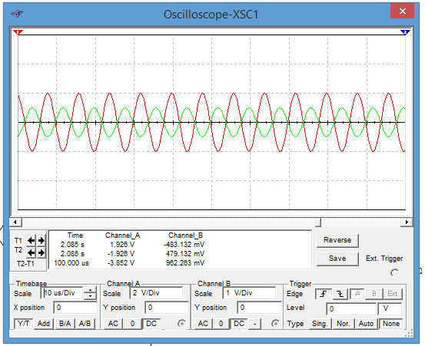

АЧХ

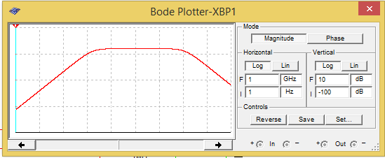

ФЧХ

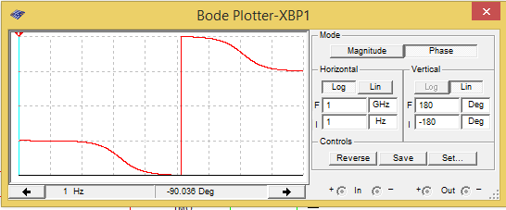

ν = 500кГц

|  |  |  |  |  |  |  |  |  |  |  |  |
| --- | --- | --- | --- | --- | --- | --- | --- | --- | --- | --- | --- |
| δС(%) | -10 | -8 | -6 | -4 | -2 | 0 | 2 | 4 | 6 | 8 | 10 |
| U | 0,283 | 0,297 | 0,311 | 0,325 | 0,339 | 0,353 | 0,368 | 0,382 | 0,396 | 0,41 | 0,424 |
| U(С пар) | 0,283 |  |  |  |  | 0,354 |  |  |  |  | 0,424 |

Схема 2

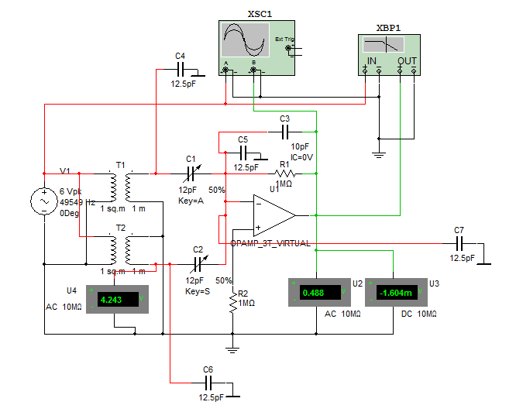

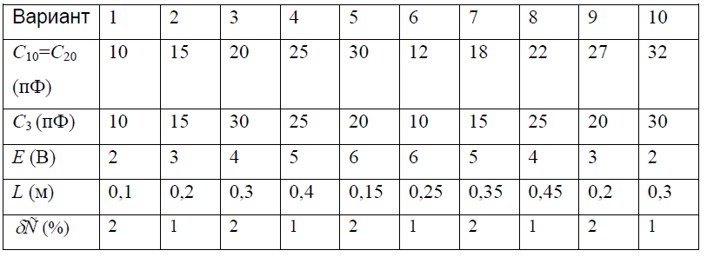

АЧХ

ФЧХ

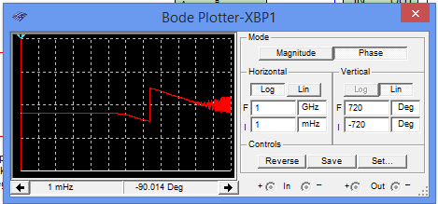

ν = 49549Гц

|  |  |  |  |  |  |  |  |  |  |  |  |
| --- | --- | --- | --- | --- | --- | --- | --- | --- | --- | --- | --- |
| δС(%) | -5 | -4 | -3 | -2 | -1 | 0 | 1 | 2 | 3 | 4 | 5 |
| U | 0,486 | 0,389 | 0,292 | 0,194 | 0,097 | 0,34*10-3 | 0,097 | 0,194 | 0,292 | 0,389 | 0,486 |
| U(С пар) | 0.488 |  |  |  |  | 0,32*10-3 |  |  |  |  | 0.488 |

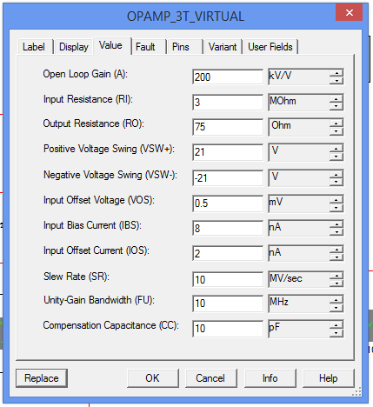

Схема 3:

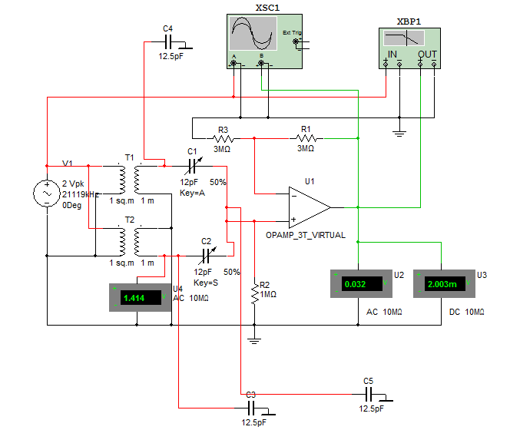

R3 = 3МОм W(OУ) = 2 => R1 = 3МОм

ν = 21911 Гц

АЧХ

ФЧХ

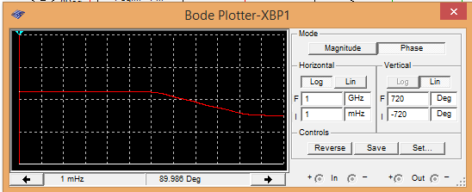

|  |  |  |  |  |  |  |  |  |  |  |  |
| --- | --- | --- | --- | --- | --- | --- | --- | --- | --- | --- | --- |
| δС(%) | -5 | -4 | -3 | -2 | -1 | 0 | 1 | 2 | 3 | 4 | 5 |
| U | 0,054 | 0,049 | 0,039 | 0,026 | 0,013 | 0 | 0,013 | 0,026 | 0,039 | 0,049 | 0,054 |
| U(С пар) | 0,032 |  |  |  |  | 0 |  |  |  |  | 0,032 |

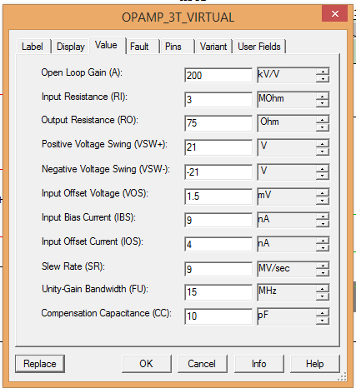

M-file:  
close all

clear

clc

U = [0.283 0.297 0.311 0.325 0.339 0.353 0.368 0.382 0.396 0.41 0.424];

dC = -10:2:10;

plot(dC,U,'*-');

xlabel('dC');

ylabel('U');

grid on;

title('Схема 1');

figure;

U = [0.486 0.389 0.292 0.194 0.097 0.34*10^(-3) 0.097 0.194 0.292 0.389 0.486];

dC = -5:1:5;

plot(dC,U,'*-')

xlabel('dC');

ylabel('U');

grid on;

title('Схема 2');

figure;

U = [0.054 0.049 0.039 0.026 0.013 0 0.013 0.026 0.039 0.049 0.054];

dC = -5:1:5;

plot(dC,U,'*-')

xlabel('dC');

ylabel('U');

grid on;

title('Схема 3');

